Supplementary Tables and Figures

Supplementary Table 1. Diagnosis codes for fracture.
Supplementary Table 2. Type of osteoporosis medication.
Supplementary Table 3. Proportions of patients treated osteoporosis medication within 2 years after the first recurrent osteoporotic fracture.
Supplementary Table 4. Medical possession ratio of osteoporosis medication within 2 years after the recurrent osteoporotic fracture.
Supplementary Table 5. The result of sensitivity analysis: the discontinuation rate of osteoporosis medication within 2 years after the first recurrent osteoporotic fracture.

Supplementary Figure 1. Study design.
Supplementary Figure 2. Definition of the first drug treatment episode and the treatment duration.
Supplementary Figure 3. Cohort selection flowchart.
Supplementary Figure 4. The probability of on-treatment by sex.
Supplementary Figure 5. The probability of on-treatment by types of drugs.

This supplementary material has been provided by the authors to give readers additional information about their work.
Supplementary Table 1. Diagnosis codes for fracture.
ICD-10 code* | Description
M484 | Fatigue fracture of vertebra
M485 | Collapsed vertebra NEC
M800 | Postmenopausal osteoporosis with pathological fracture
M801 | Postoophorectomy osteoporosis with pathological fracture
M802 | Osteoporosis of disuse with pathological fracture
M803 | Postsurgical malabsorption osteoporosis with pathological fracture
M805 | Idiopathic osteoporosis with pathological fracture
M808 | Other osteoporosis with pathological fracture
M809 | Unspecified osteoporosis with pathological fracture
S220 | Fracture of thoracic vertebra
S221 | Multiple fracture of thoracic spine
S320 | Fracture of lumbar vertebra
S321 | Fracture of sacrum
S328 | Fracture of other and unspecified parts of lumbar spine and pelvis
S422 | Fracture of upper end of humerus
S423 | Fracture of shaft of humerus
S424 | Fracture of lower end of humerus
S525 | Fracture of lower end of radius
S526 | Fracture of lower end of both ulna and radius
S720 | Fracture of neck of femur
S721 | Pertrochanteric of femur fracture
S724 | Fracture of lower end of femur
S823 | Fracture of lower end of tibia
S825 | Fracture of medial malleolus
S826 | Fracture of lateral malleous
Abbreviation: ICD-10, International Classification of Diseases 10th

Supplementary Table 2. Type of osteoporosis medication.

The osteoporosis medication analyzed in this study included various types, such as bisphosphonates, selective estrogen receptor modulators, denosumab, and teriparatide. The detailed generic name is below.

Type of osteoporosis medication | Generic name
SERM | Raloxifene
SERM | Raloxifene with cholecalciferol
SERM | Bazedoxifene
SERM | Bazedoxifene with cholecalciferol
BP oral | Alendronate
BP oral | Alendronate with cholecalciferol
BP oral | Risedronate
BP oral | Risedronate with cholecalciferol
BP oral | Ibandronate
BP oral | Ibandronate with cholecalciferol
BP 3-monthly Inj. | Pamidronate
BP 3-monthly Inj. | Ibandronate
BP yearly Inj. | Zoledronate
Parathyroid hormone | Teriparatide
RANK inhibitor | Denosumab
Abbreviation: BP, Bisphosphonate; Inj., injection type; RANK, Receptor activator of nuclear factor-kB; SERM, Selective Estrogen Receptor Modulator.

Supplementary Table 3. Proportions of osteoporosis medication within 2 years after the recurrent osteoporotic fracture between male and woman.

 | Total |  |  |  |  | Male |  |  |  |  | Woman
 |  | No. of 1st recurrent OF | No. of treated | % of treated | P-value ª |  | No. of 1st recurrent OF | No. of treated | % of treated | P-value ª |  | No. of 1st recurrent OF | No. of treated | % of treated | P-value ª
 |  | 34,558 | 18,462 | 53.42 | - |  | 5,261 | 1,247 | 23.70 | - |  | 29,297 | 17,215 | 58.76 | -
Age group
55≤Y<65 |  | 7,306 | 2,467 | 33.77 | <0.001 |  | 1,734 | 1,734 | 10.38 | <0.001 |  | 5,572 | 2,252 | 41.04 | <0.001
65≤Y<75 |  | 10,826 | 6,368 | 58.82 |  |  | 1,662 | 1,662 | 23.29 |  |  | 9,164 | 5,862 | 65.27 | <0.001
75≤Y<85 |  | 12,358 | 7,749 | 62.70 |  |  | 1,461 | 1,461 | 37.65 |  |  | 10,897 | 7,053 | 66.06 | <0.001
85≤Y |  | 4,068 | 1,878 | 46.17 |  |  | 404 | 404 | 32.18 |  |  | 3,664 | 1,707 | 47.71 | <0.001
Abbreviations: OP, Osteoporosis medication; OF, Osteoporotic fracture
a: P-values for columns within each group
P-values for the difference of age stratified medication rate between males and females Chi square P<0.0624| Fisher= p<0.583

Supplementary Table 4. Medical possession ratio of osteoporosis medication within 2 years after the recurrent osteoporotic fracture.
 | Median | Mean | SD | IQR | MPR<0.2 |  | 0.2 ≤ MPR < 0.4 |  | 0.4 ≤ MPR < 0.6 |  | 0.6 ≤ MPR < 0.8 |  | 0.8 ≤ MPR
 |  |  |  |  | No. treated OP | Row  proportion (%) | No. treated OP | Row  proportion (%) | No. treated OP | Row  proportion (%) | No. treated OP | Row  proportion (%) | No. treated OP | Row  proportion (%)
Total | 0.20 | 0.32 | 0.30 | 0.08-0.50 | 9,229 | 49.99 | 3,470 | 18.80 | 1,867 | 10.11 | 1,256 | 6.80 | 2,640 | 14.30
SERM | 0.25 | 0.35 | 0.31 | 0.10-0.56 | 747 | 45.33 | 314 | 19.05 | 208 | 12.62 | 121 | 7.34 | 258 | 15.66
BP daily oral | 0.08 | 0.21 | 0.26 | 0.03-0.27 | 533 | 68.51 | 104 | 13.37 | 53 | 6.81 | 33 | 4.24 | 55 | 7.07
BP weekly oral | 0.15 | 0.28 | 0.29 | 0.05-0.42 | 5,457 | 57.57 | 1545 | 16.30 | 849 | 8.96 | 591 | 6.23 | 1037 | 10.94
BP monthly oral | 0.25 | 0.34 | 0.30 | 0.12-0.50 | 677 | 43.82 | 345 | 22.33 | 192 | 12.43 | 109 | 7.06 | 222 | 14.37
BP 3monthly Inj. | 0.25 | 0.42 | 0.32 | 0.13-0.73 | 1,784 | 37.62 | 1133 | 23.89 | 390 | 8.22 | 389 | 8.20 | 1046 | 22.06
BP yearly Inj. | 0.50 | 0.48 | 0.21 | 0.45-0.50 | 28 | 10.49 | 29 | 10.86 | 175 | 65.54 | 13 | 4.87 | 22 | 8.24
Teriparatide daily Inj. | 0.04 | 0.06 | 0.05 | 0.2-0.12 | 3 | 100.00 | 0 | 0.00 | 0 | 0.00 | 0 | 0.00 | 0 | 0.00

Supplementary Table 5. The result of sensitivity analysis: the discontinuation rate of osteoporosis medication within 2 years after the first recurrent osteoporotic fracture.
 |  | Refill gap: 3 months |  | Refill gap: 6 months
 |  | Within 2 years |  | Within 2 years
 | No. of treated patient | No. of  patient discontinued medication | Discontinuation rate (%) | No.  discontinued OP | Discontinuation rate (%)
Total | 18,462 | 14,409 | 78.05% | 13,678 | 74.09%
SERM | 1,648 | 1,244 | 75.49% | 1,177 | 71.42%
BP daily oral | 778 | 691 | 88.82% | 677 | 87.02%
BP weekly oral | 9,479 | 7,801 | 82.30% | 7,449 | 78.58%
BP monthly oral | 1,545 | 1,188 | 76.89% | 1,126 | 72.88%
BP 3-monthly Inj. | 4,742 | 3,335 | 70.33% | 3,105 | 65.48%
BP yearly Inj. | 267 | 148 | 55.43% | 142 | 53.18%
Teriparatide daily Inj. | 3 | 2 | 66.67% | 2 | 66.67%

Supplementary Figure 1. Study design and follow-up timeline. The figure illustrates the wash-out period (2012), index-fracture identification period (2013), recurrent-fracture ascertainment period, and 2-year follow-up for osteoporosis medication utilization and treatment outcomes after the first recurrent osteoporotic fracture.
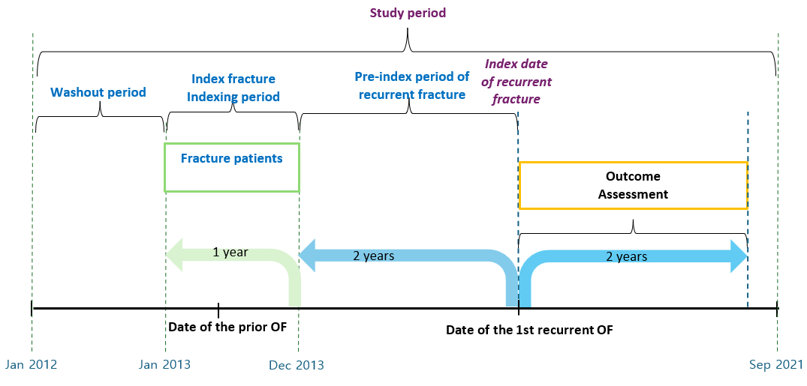

OF, Osteoporotic fracture

Supplementary Figure 2. Definition of the first drug treatment episode and the treatment duration
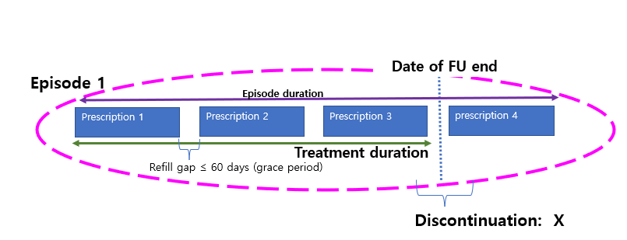

To analyze the initial osteoporosis treatment patterns among the recurrent OF cohort, we defined the initial osteoporosis treatment as the first treatment episode, allowing a 60-day refill gap between prescriptions. The end of treatment was defined as the earliest event, either the last date of drug use during the first treatment episode or the latest follow-up date. The first treatment episode was defined as the continuous prescription of the initial osteoporosis medication during the follow-up period, starting from the first recurrent OF. Continuity of prescription was defined as the uninterrupted prescription of the same medication as the initial osteoporosis medication within the 60-day refill gap (or grace period) between two consecutive prescriptions. Discontinuation of treatment corresponds to the termination of the initial treatment episode. Any patient whose first treatment episode extended beyond the two-year follow-up period was deemed not discontinued. The treatment duration was defined as the shortest period from the first date of an osteoporosis drug prescription to the earliest date of the latest follow-up, the date of drug change, or discontinuation of the first drug.

Supplementary Figure 3. Cohort selection flowchart.

Selection of the entire cohort |  | Patients ≥ 55 years with fractures between Jan 2013 and Dec 2013  (N = 590,535)
Selection of the entire cohort |  |  |  |  |  | Excluded if  1) Patients diagnosed with cancer (except non-melanoma skin cancer), Paget’s disease, or metabolic bone diseases during the study period (N = 138,345)  2) Patients diagnosed with OFs during the wash-out period (N=141,506)  3) Patients died within two years of the 1st recurrent OF (N=4,782)  4) Others† (N=105,888)
Selection of the entire cohort |  | < Entire cohort >  Patients aged ≥ 55 with a primary OF diagnosis between Jan 2013 and Dec 2013  (N = 200,014)
Selection of the interest cohort |  |  |  |  |  | Excluded if  1) patients without 1st recurrent OF diagnosis (N=122,403)  2) Patients diagnosed with 1st recurrent OF after two years of the index OF (N=46,331)
Selection of the interest cohort |  | < Recurrent OF cohort >  Patients aged ≥ 55 with a primary OF diagnosis between Jan 2013 and Dec 2013 and with the 1st recurrent OF within two years of the primary OF  (N = 34,558)
Abbreviation: OF, osteoporotic fracture
† Patients without OFs diagnosis(femur, vertebra, radius, humerus, pelvis(hip), sacrum, and ankle fracture) during the study period and patients with a primary OF diagnosis after 2013

Supplementary Figure 4. The probability of on-treatment by sex.

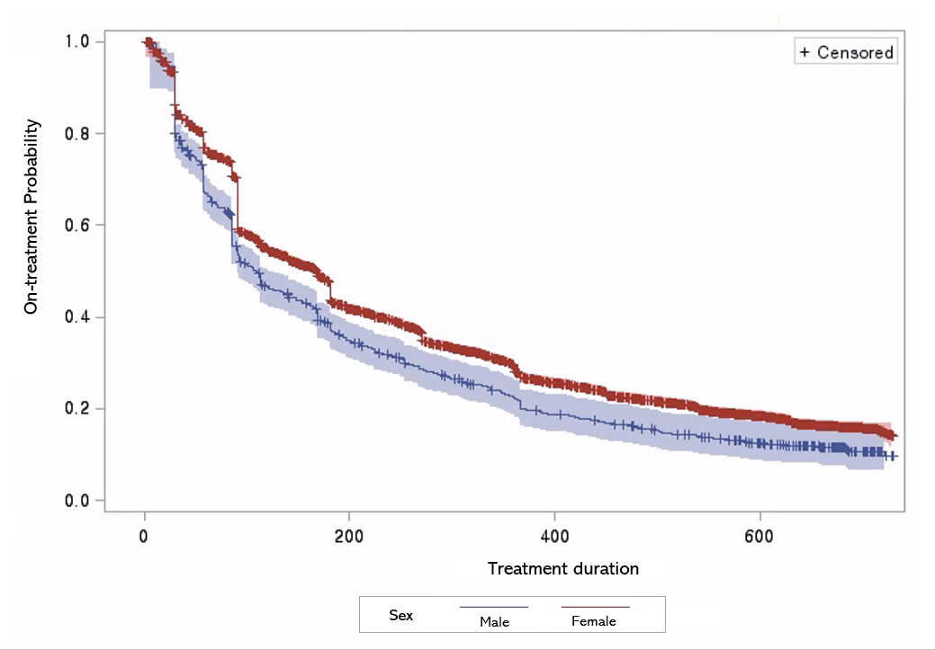
Log-rank test p-value <0.0001

Supplementary Figure 5. The probability of on-treatment by types of drugs.

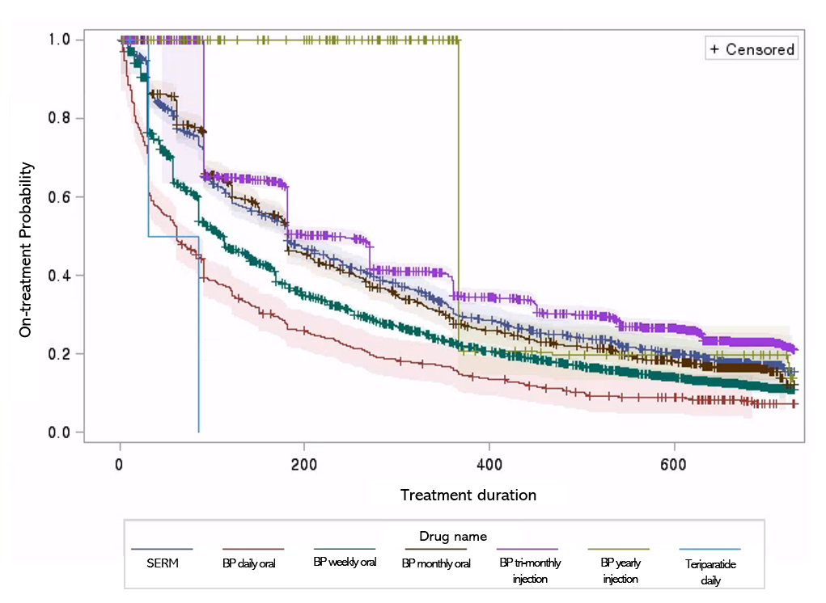
Log-rank test p-value <0.0001

